**DAILY ONLINE ACTIVITIES SUMMARY**

|  |  |  |  |  |  |  |  |  |
| --- | --- | --- | --- | --- | --- | --- | --- | --- |
| **Date:** | **20-5-2020** | | | | | **Name:** | **Likhitha.M** | |
| **Sem & Sec** | **6th sem ‘A’** | | | | | **USN:** | **4al17cs046** | |
| **Online Test Summary** | | | | | | | | |
| **Subject** | | **System software and compiler design** | | | | | | |
| **Max. Marks** | | **30** | | **Score** | | | **21** | |
| **Certification Course Summary** | | | | | | | | |
| **Course** | **Python for machine learning** | | | | | | | |
| **Certificate Provider** | | | **Greate learning** | | **Duration** | | | **1 week** |
| **Coding Challenges** | | | | | | | | |
| **Problem Statement:**  **1.Write a c program to Reverse the Linked list in groups of given size.**  Test Case 1: If a linked listis: 1 → 2 → 3 → 4 → 5 → 6 → 7 → 8 The value of size k is 2 Then the linked list looks like: 2 → 1 → 4 → 3 → 6 → 5 → 8 → 7  Test Case 2: If a linked listis: 1 → 2 → 3 → 4 → 5 → 6 → 7 → 8 The value of size k is 3 Then the linked list looks like: 3 → 2 → 1 → 6 → 5 → 4 → 8 → 7  2.Python Program to Exchange the Values of Two Numbers using ^ (exclusive or operator)  3.Write Python Program to Reverse a Given Number This is a Python Program to reverse a given number. Problem Description The program takes a number and reverses it and store it in another variable and show it | | | | | | | | |
| **Status:** | | | | | | | | |
| **Uploaded the report in Github** | | | | | **yes** | | | |
| **If yes Repository name** | | | | | **https://github.com/likhithaMantaral/Daily-status** | | | |
| **Uploaded the report in slack** | | | | | **yes** | | | |

Online Test Details:

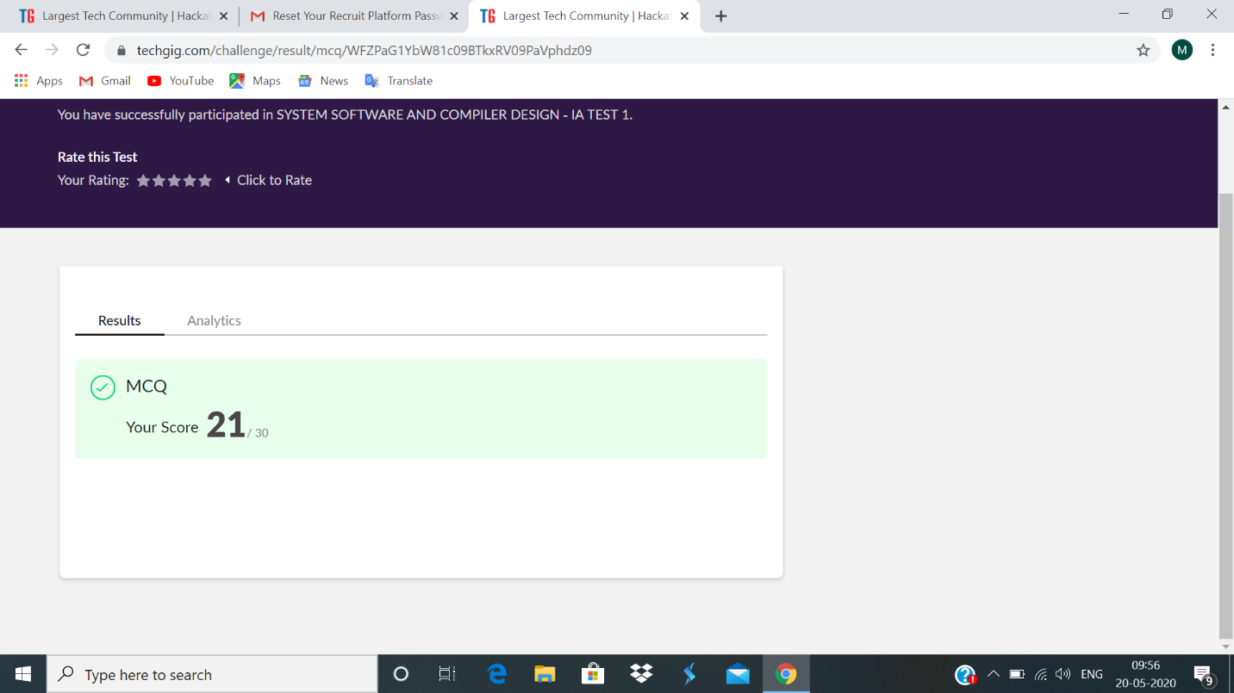

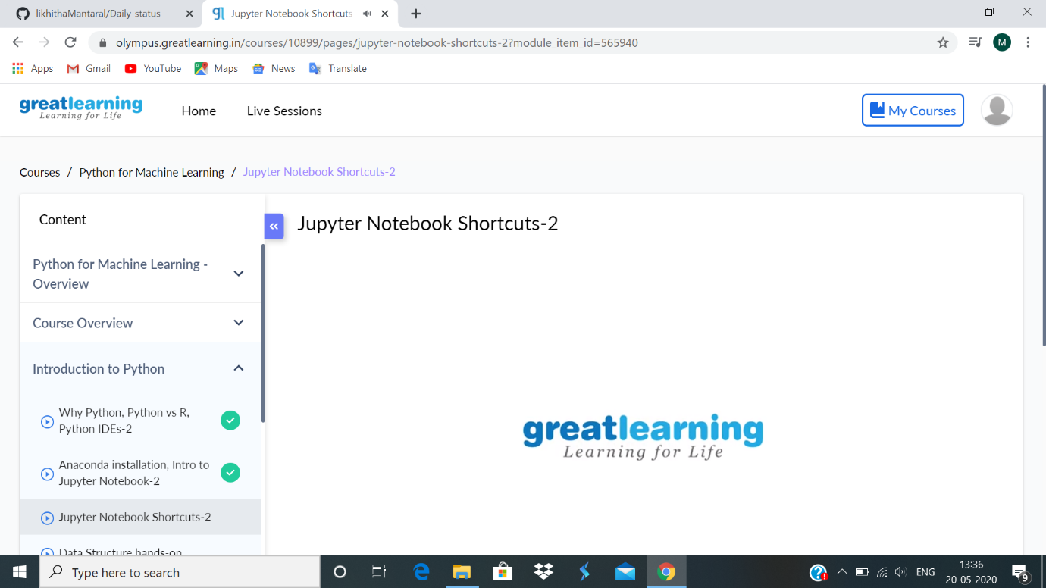Certification Course Details:

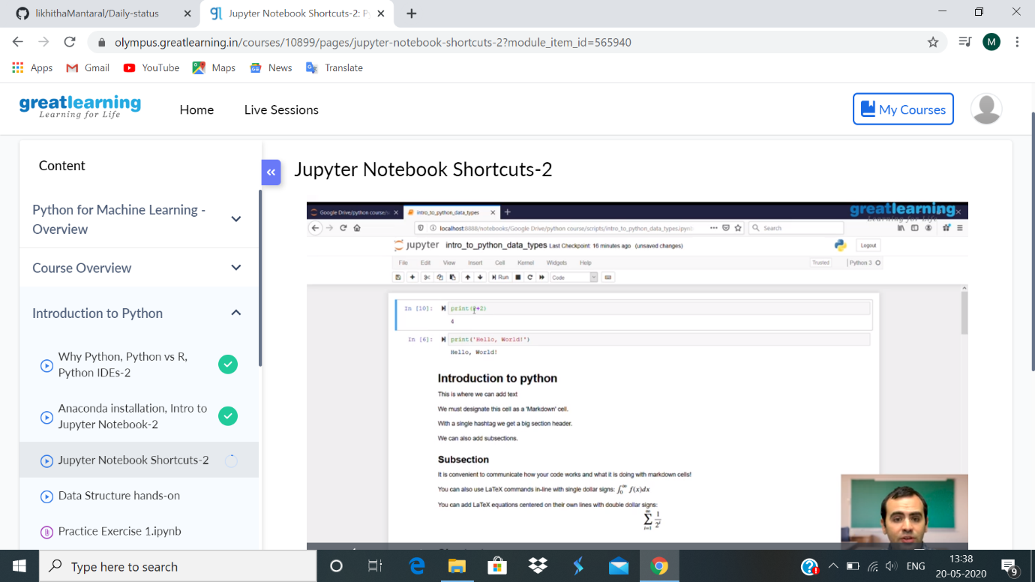

Learnt how to launch new notebook in Jupyter. There are different ways to run the code. Kernel is used as a compiler in jupyter. Under the cell we can write the text, but it must be designated by ‘markdown’ cell. We can write equations using ‘letex’ command. It is convenient to communicate how your code works and what it is doing with markdown cell. Learnt about some important keyboard shortcuts like shift+enter, ctrl+enter etc.

Coding Challenges Details:

